Online GISc course
Creating a dashboard using QGIS
The online one (1) day GISc course will provide participants with the knowledge to use QGIS to create graphs and tables that can be used as a dashboard for projects. The dashboard is linked to a geographical area based on a created atlas.
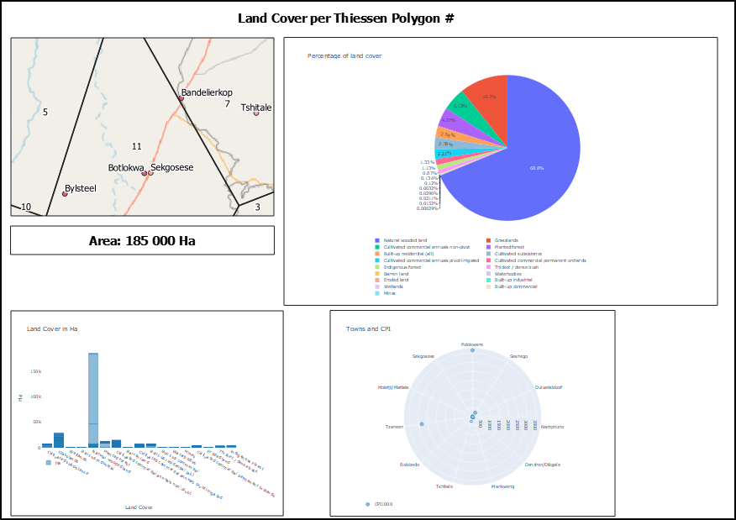
Course program
- Course outlay.
- Important GISc concepts.
- QGIS introduction.
- Prepare the database for analysis (Geopackage/File Geodatabase),
  - Capture data,
  - Manage data,
  - Etc.
- Creating a dashboard by constructing graphs and atlases.
Costing
Costing for the course will apply a tier mechanism to calculate the cost of attending the training:
- Tier 1 will include training and training material. Cost = R750 per day.
- Tier 2 will include training, training material and one (1) hours of consultation after the training is completed. Cost = R1 000 per day.
- Tier 3 will include training, training material and two (2) hours of consultation after the training is completed. Cost = R1 800 per day.
The consultation will be for six months after the completion of the course. Other consultations can be booked here.
Date
The course will take place from 22 June 2021.
Booking
Please book here:
Here

